Noise-augmented training: robustness to imperfect phoneme input
Project: homophone-aware phoneme-to-text decoding for lip-reading Date: 23 July 2026 Model: Llama-3.2-3B with low-rank adapters, beam search width 5

Summary
The decoder is trained on perfect phoneme transcriptions, but in a working lip-reading system the phonemes come from a visual front-end that makes mistakes. This report asks how the decoder holds up when its input is imperfect, and whether deliberately training on imperfect input helps.
Two decoders were compared. The first was trained on clean phonemes. The second was trained with half its input phonemes deliberately corrupted, a standard robustness technique. Both were then tested on the same sentences at increasing levels of input corruption.
The clean-trained decoder is fragile. Corrupting just one phoneme in twenty drops its exact-match accuracy from 93% to between 19% and 46%, depending on the type of corruption. The decoder trained on corrupted input is far more durable, holding 58% to 81% under the same conditions. This robustness costs about 4 points of accuracy on perfect input, which is a favourable trade for any deployment where the input will not be perfect.

Why this matters
A phoneme-to-text decoder never sees perfect input in practice. The phonemes it receives are the output of an earlier visual recognition stage, and that stage mislabels sounds, misses them, or adds spurious ones. A decoder that performs well only on flawless input would perform poorly in the complete system. The question is therefore not only how accurate the decoder is, but how gracefully it degrades when its input is disturbed.

Method
Both decoders share the same base model, the same training data, the same three training epochs, and the same beam-search decoding. They differ in one respect. The clean model saw only correct phoneme sequences. The robust model had half of its training sentences corrupted, each by one of three operations at a randomly chosen level between 5% and 15%:
- substitution, standing in for a sound the front-end misheard - deletion, for a sound the front-end missed - insertion, for a sound the front-end added in error
Both models were then evaluated on 300 held-out sentences under a clean control and under each of the three corruptions at 5%, 10% and 20%. Corruption was applied only to the test input; the reference sentences were never altered.

Result 1: the clean-trained decoder is fragile
On perfect input the clean-trained decoder reaches 93% exact match. A small amount of input corruption removes most of that accuracy.
Corruption at 5% | Clean-trained exact match
Substitution | 19.3%
Deletion | 33.0%
Insertion | 46.0%

One corrupted phoneme in twenty is enough to more than halve the decoder's accuracy, and in the substitution case to remove three quarters of it. This tells us the clean-trained decoder depends heavily on receiving an exact phoneme sequence, which is the condition a real front-end cannot guarantee.

Result 2: training on corrupted input restores durability
The decoder trained on corrupted input degrades far more gently.
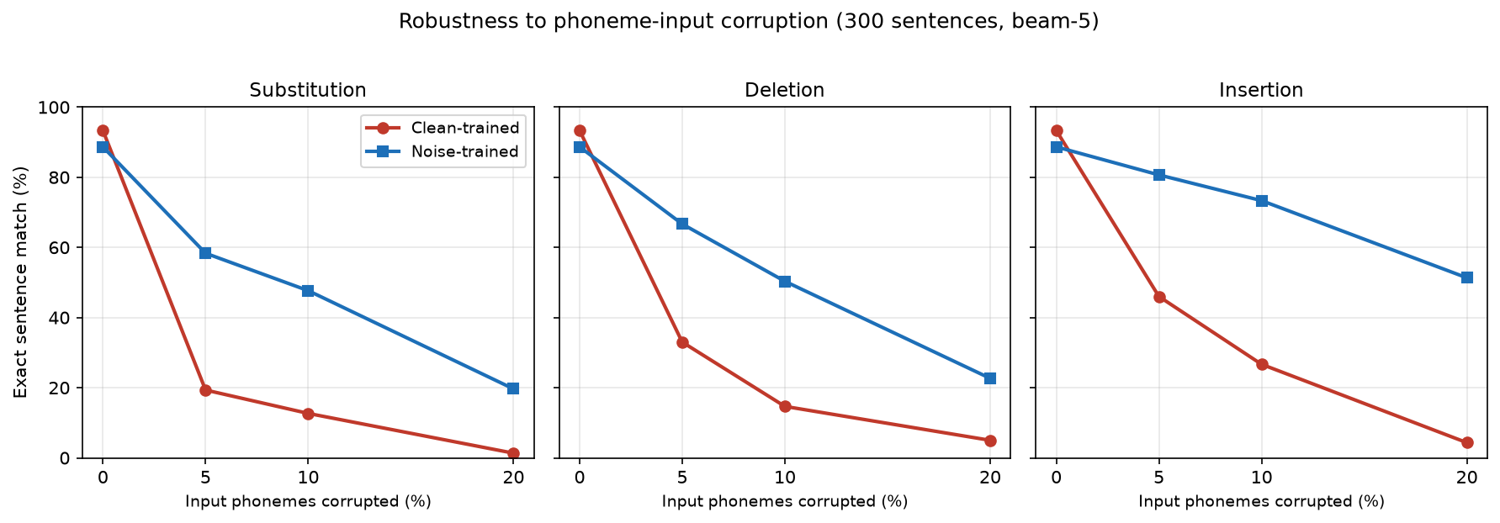
Exact-match accuracy as input corruption increases, for each corruption type. The clean-trained decoder (red) falls sharply once any corruption is present; the noise-trained decoder (blue) declines gradually. Both start from the same point on clean input.
Reading the figure, both decoders begin together at zero corruption. As soon as corruption appears, the clean-trained decoder drops steeply while the robust decoder declines gradually. The gap between them is the benefit of training on imperfect input, and it is large at every corruption level and every corruption type.
Condition | Clean-trained | Noise-trained | Gain
Substitution 5% | 19.3% | 58.3% | +39.0
Substitution 10% | 12.7% | 47.7% | +35.0
Substitution 20% | 1.3% | 19.7% | +18.4
Deletion 5% | 33.0% | 66.7% | +33.7
Deletion 10% | 14.7% | 50.3% | +35.6
Deletion 20% | 5.0% | 22.7% | +17.7
Insertion 5% | 46.0% | 80.7% | +34.7
Insertion 10% | 26.7% | 73.3% | +46.6
Insertion 20% | 4.3% | 51.3% | +47.0

Insertion is the mildest corruption for both decoders, because an added phoneme leaves the real ones intact. Substitution is the harshest, because it replaces a real sound with a misleading one. The robust decoder outperforms the fragile one across all three.

Result 3: the cost on clean input is small
Robustness is not free. On perfect input the robust decoder scores slightly below the clean one.
Evaluation | Clean-trained | Noise-trained | Cost
300-sentence control | 93.3% | 88.7% | 4.7
Full 949-sentence validation | 92.0% | 88.7% | 3.3

A drop of three to five points on perfect input buys a gain of 18 to 47 points once the input is disturbed. For any setting where the phonemes arrive from an imperfect source, which is every real deployment, the trade favours the robust decoder.

Training behaviour
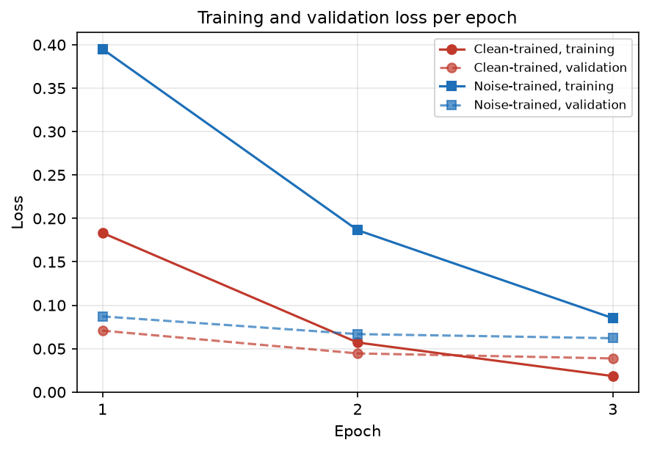
Training and validation loss per epoch for both decoders. The noise-trained decoder settles at a higher loss because half its training inputs are corrupted, making the task harder.
The robust decoder settles at a higher training loss, which is expected: when half the input sentences are corrupted, some no longer contain enough information to recover the target perfectly, so the loss cannot fall as far. Validation loss declined every epoch for both decoders with no upturn, so neither overfit and both were still improving when training stopped.

Conclusion and next steps
Training on imperfect phoneme input makes the decoder substantially more robust to the kind of errors a visual front-end produces, at a small cost to accuracy on perfect input. For the complete lip-reading system, where perfect input never arrives, this is the more useful decoder.
Two directions follow. The corruption used here is uniform across all sounds, whereas a real front-end confuses specific sounds that look alike on the lips; matching the training corruption to those confusions should improve realism. Final accuracy figures should also be confirmed on the held-out test set, which has not yet been used.

Notes on the numbers
Robustness figures are measured on 300 sentences with a fixed random seed, so the two decoders are compared on identical inputs. The full-validation figures use 949 sentences. All evaluation uses beam-search decoding. Corruption is applied only to the test input, and each corruption level is tested against a clean control on the same sentences.

The robustness technique itself (multi-condition / multi-style training):
- Lippmann, R. P., Martin, E. A., & Paul, D. B. (1987). Multi-style training for robust isolated-word speech recognition. ICASSP. — the canonical origin of training on corrupted input for robustness. Verify the exact venue details.
Data augmentation for speech robustness:
- Park, D. S., Chan, W., Zhang, Y., et al. (2019). SpecAugment: A simple data augmentation method for automatic speech recognition. Interspeech. arXiv:1904.08779. — the modern precedent, though it corrupts spectrograms rather than phonemes.
The fine-tuning method:
- Hu, E. J., Shen, Y., Wallis, P., et al. (2021). LoRA: Low-Rank Adaptation of Large Language Models. arXiv:2106.09685.
- Dettmers, T., Pagnoni, A., Holtzman, A., & Zettlemoyer, L. (2023). QLoRA: Efficient Finetuning of Quantized LLMs. arXiv:2305.14314.
The corpus:
- Chung, J. S., Senior, A., Vinyals, O., & Zisserman, A. (2017). Lip Reading Sentences in the Wild. CVPR.
- Afouras, T., Chung, J. S., Senior, A., et al. (2018). Deep Audio-Visual Speech Recognition. IEEE TPAMI.

